OOP Part-2
Yash Bhandari | @behumoury
Q1.

/*
1) Write a program to print the following pattern:
6 5 4 3 2 1
6 5 4 3 2
6 5 4 3
6 5 4
6 5
6

*/
public class Q1 {
public static void main(String[] args) {

//Outer loop
for (int i = 6; i > 0; i--) {
//inner loop
for (int j = 6; j > (6-i); j--) {
System.out.print(j+" ");
}
System.out.println();
}
}
}

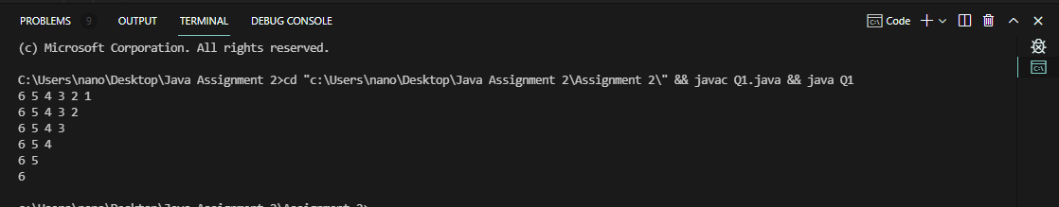

Q2.

/*2) Write a program to print the following pattern:
*
* *
* * *
* * * *
* * * * *
* * * *
* * *
* *
*
*/

public class Q2 {
public static void main(String[] args) {
int n = 5;

//prints the upper portion
for (int i = 1; i <= n; i++) {
for (int j = n-i; j > 0; j--) {
System.out.print(" ");
}

for (int j = 0; j < i; j++) {
System.out.print("* ");
}
System.out.println();
}

//prints the lower half
for (int i = 1; i < n; i++) {
for (int j = 0; j < i; j++) {
System.out.print(" ");
}

for (int j = n; j > i; j--) {
System.out.print("* ");
}
System.out.println();
}
}
}

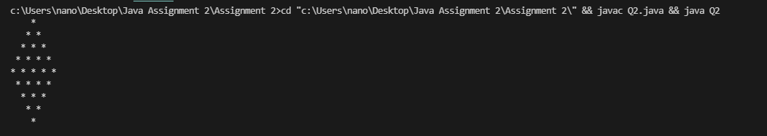

Q3.

// 3) Write a program to display Fibonacci series up to a given term.
import java.util.Scanner;

public class Q3 {

// Calculate fabbonacii term with recursion
public static int fabonacii(int n) {
if (n == 0 || n == 1) {
return n;
}
return fabonacii(n - 1) + fabonacii(n - 2);
}

public static void main(String[] args) {
Scanner s = new Scanner(System.in);
int n = s.nextInt();

// Print fabonnaci term
for (int i = 0; i < n; i++) {
System.out.print(fabonacii(i) + " ");
}
}
}

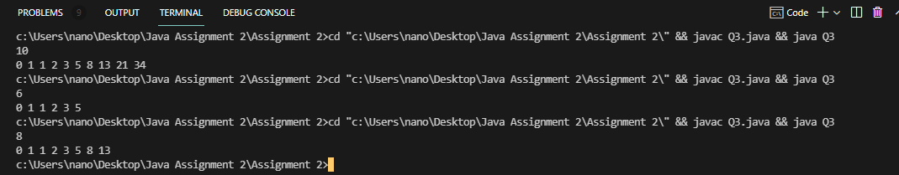

Q4.

/*
4) Write a program to print the following pattern:
(a)
(a + b)
(a + b + c)
(a + b + c + d)
(a + b + c + d + e)
(a + b + c + d + e + f)
*/

public class Q4 {
public static void main(String[] args) {
int ascii_of_a = (int)'a';
int n = 6;

//Print the pattern
for (int i = 1; i <= n; i++) {
System.out.print("(a");
for (int j = 1; j < i; j++) {
System.out.print(" + " + (char)(ascii_of_a + j));
}
System.out.print(")");
System.out.println();
}
}
}

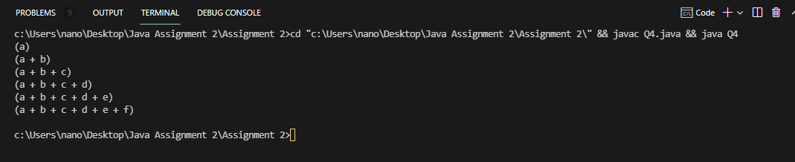

Q5.

import java.util.Scanner;

//5) Write a program to print sum of series (i.e. 0, 1, 4, 9, 16…).

public class Q5 {

//function to calculate sum of series
public static int sum_series(int n){
int sum = 0;
for (int i = 0; i < n; i++) {
sum += (int)Math.pow(i, 2);
}
return sum;
}
public static void main(String[] args) {
int n;
Scanner sc = new Scanner(System.in);

//gets no. of terms to calculate sum till
n = sc.nextInt();

//Sum and print
System.out.println("The sum is: " + sum_series(n));
}
}

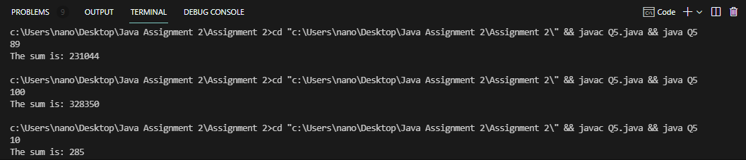

Q6.

import java.util.Scanner;

//6) Write a program to print sum of series (i.e. 1 + 1/1! + 2/2! + 3/3! + 4/4! +…..).

public class Q6 {

//Calculates factorial of number by recursion
public static int fact(int n){
if (n == 0 || n == 1) {
return 1;
}

return n*fact(n-1);
}

//Calculates the sum of the series
public static double sum_series(int n){
double sum = 1;

for (int i = 1; i < n; i++) {
sum += (double)i/fact(i);
}

return sum;
}
public static void main(String[] args) {
Scanner sc = new Scanner(System.in);
int n = sc.nextInt();
System.out.println("The sum is: " + sum_series(n));
}
}

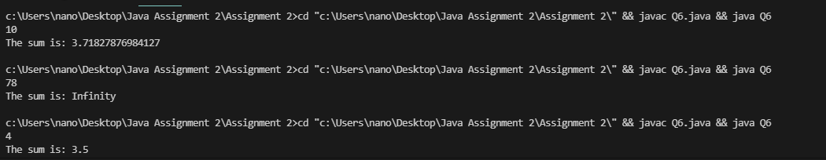

Q7.

//7) Write a program to demonstrate widening and narrowing in java.

public class Q7 {
public static void main(String[] args) {

//Widening
int a = 45;
long b = a;
double c = b;

System.out.println("a = " + a);
System.out.println("b = " + b);
System.out.println("c = " + c);

//Narrowing - Require type casting
long d = 150000;
int e = (int)d;

System.out.println("d = " + d);
System.out.println("e = " + e);
}
}

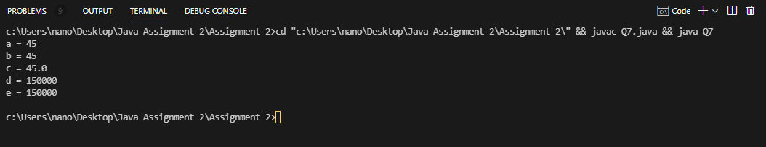

Q8.

//8) Write a program to find sum of natural numbers from 1 to 100.

public class Q8 {
public static void main(String[] args) {
int sum = 0;
for (int i = 1; i <= 100; i++) {
sum += i;
}

System.out.println("The sum is: " + sum);
}
}

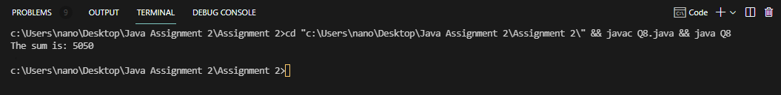
Q9.

import java.util.Scanner;

//9) Write a program to calculate the sum of numbers entered by the user until user enters 0.

public class Q9 {

//calcultes the sum till n numbers
public static int sum(int n){
int sum = 0;
for (int i = 1; i <= n; i++) {
sum += i;
}

return sum;
}
public static void main(String[] args) {
Scanner sc = new Scanner(System.in);
int n = 0;
do{
n = sc.nextInt();
System.out.println("The sum is: " + sum(n));
}
while(n != 0);

System.out.println("Exit!");
}
}

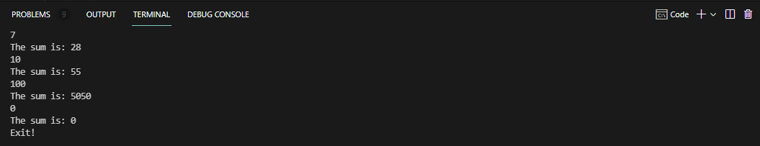

Q10.

import java.nio.file.*;
import java.io.IOException;
//10) Write a program to find the size of a specified file.

public class Q10 {
public static void main(String[] args) throws IOException {
//Creates the path for file

Path p = Paths.get("C:\\Users\\nano\\Desktop\\Java Assignment 2\\Assignment 2\\File.txt");

try {
long size = Files.size(p);
System.out.println("File Size = " + size + " bytes");
} catch (Exception e) {
e.getStackTrace();
}
}
}

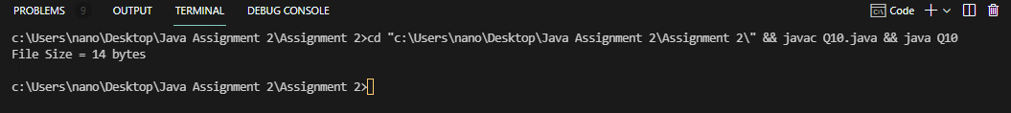

Q11.

import java.time.LocalDateTime;
import java.time.format.DateTimeFormatter;

// Write a program to display the current date time in specific format.

public class Q11 extends Thread{
public static void main(String[] args) {
LocalDateTime dt = LocalDateTime.now();

//Date time formater
DateTimeFormatter df = DateTimeFormatter.ofPattern("dd.MM.yyyy");
String date = dt.format(df);

//printing formated date
System.out.println(dt);
}
}

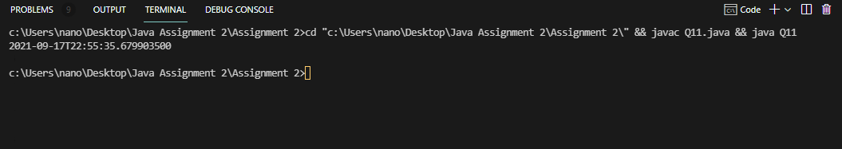
Q12.

import java.util.Scanner;

//12) Write a program to calculate the sum of two integers and return true if the sum is equal to a third integer.

public class Q12 {

public static String check(int a,int b,int c){
if(a+b == c){
return "True";
}
else
return "False";
}
public static void main(String[] args) {
Scanner sc = new Scanner(System.in);
int a = sc.nextInt();
int b = sc.nextInt();
int c = sc.nextInt();

System.out.println(check(a,b,c));
}
}

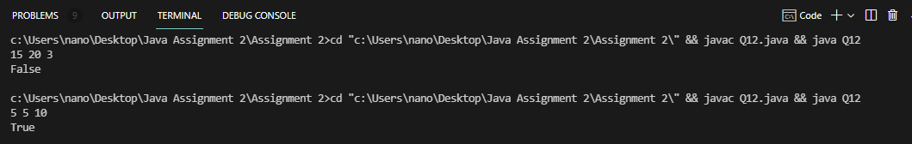

Q13.

import java.util.Scanner;

//13) Write a program to convert decimal to binary equivalent.

public class Q13 {

public static void convert_To_Binary(int n){
String ans = "";
Integer rem;
while (n!=0) {
rem = n%2;
ans += rem.toString(rem);
n = n/2;
}

char[] arr = ans.toCharArray();

for (int i = arr.length - 1; i >= 0; i--)
System.out.print(arr[i]);
}
public static void main(String[] args) {
Scanner sc = new Scanner(System.in);
int n = sc.nextInt();

convert_To_Binary(n);
}
}

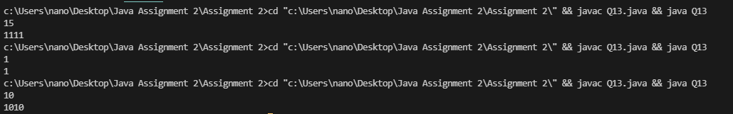

Q14.

// Write a program to convert binary to octal equivalent.
import java.util.*;

public class Q14 {

//retruns to octal number after conversion
public static int binary_to_octal(int binary) {
int octal = 0, decimal = 0, i = 0;

///converts binary to decimal
while (binary != 0) {
decimal += (binary % 10) * Math.pow(2, i);
++i;
binary /= 10;
}

i = 1;

//converts decimal to octal
while (decimal != 0) {
octal += (decimal % 8) * i;
decimal /= 8;
i *= 10;
}

return octal;
}

public static void main(String[] args) {
Scanner sc = new Scanner(System.in);
System.out.print("Enter the binary number : ");
int binary = sc.nextInt();
System.out.print("\nEquivalent octal number :" + binary_to_octal(binary));
}

}

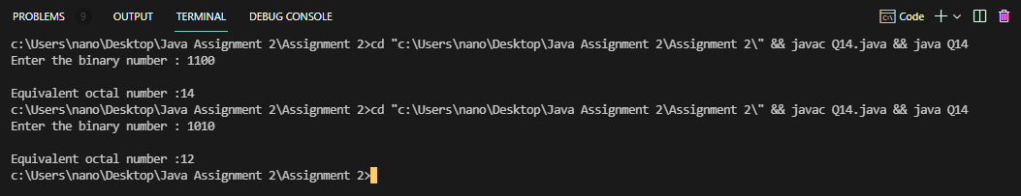

Q15.

// 15) Write a program to find factorial of 60.

public class Q15 {
// Function to find factorial of 60
static void factorial(int n) {
int res[] = new int[500];

// Initialize result
res[0] = 1;
int res_size = 1;

// n! = 1 * 2 * 3 * 4...*n
for (int x = 2; x <= n; x++)
res_size = multiply(x, res, res_size);

System.out.println("Factorial of given number is ");
for (int i = res_size - 1; i >= 0; i--)
System.out.print(res[i]);
}

// function to multipl x with the number represented by res[] and size res_size
static int multiply(int x, int res[], int res_size) {
int carry = 0; // Initialize carry

// One by one multiply n with individual digits of res[]
for (int i = 0; i < res_size; i++) {
int prod = res[i] * x + carry;
res[i] = prod % 10; // Store last digit of 'prod' in res[]
carry = prod / 10; // Put rest in carry
}

// Put carry in res and increase result size
while (carry != 0) {
res[res_size] = carry % 10;
carry = carry / 10;
res_size++;
}
return res_size;
}

//Main Class
public static void main(String args[]) {
factorial(60);
}
}

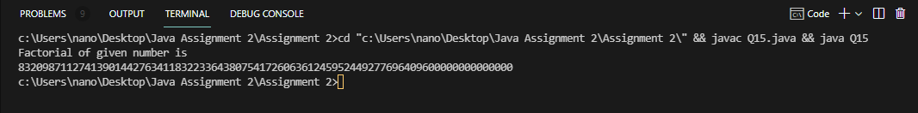

Q16.
import java.math.BigInteger;

//16) Write a program to check whether the following number is prime or not: 21000254869723212850.

public class Q16 {
public static void main(String[] args) {
// long l = 21000254869723212850; cannot store this number
//Create big integer and stores value to it
BigInteger big_Int = new BigInteger("21000254869723212850");

//Certainity = 1
if (big_Int.isProbablePrime(1)) {
System.out.println("Prime");
}
else
System.out.println("Not Prime");
}
}

